**URGENT HEALTHCARE APPLICATION**

**Client/Sponsor:** Iyka Enterprises Inc.

**Project Overview:** When someone is hurt, and you have to go to urgent care, there might be other people over there too and you don't know which urgent care facility is closest to you. Sometimes the urgent care wait time can be around 3 hours long. For making emergency times a little less stressful, this project involves the development of an application named “URGENT” which would use machine learning algorithms including k-Nearest Neighbors and Time Series Forecasting to recommend the nearest and lowest wait time urgent care facilities so that patients can feel a sense of ease of transportation that an emergency room patient might feel.

**Business Perspective**: The sponsor took up this project last year and a business vision to launch or sell this application for monetary gains. There is no such application in the US market and this would be one of such with a potential to help people in the worst of situations and also, earn a good profit margin.

**Original Gantt chart and Plan:**

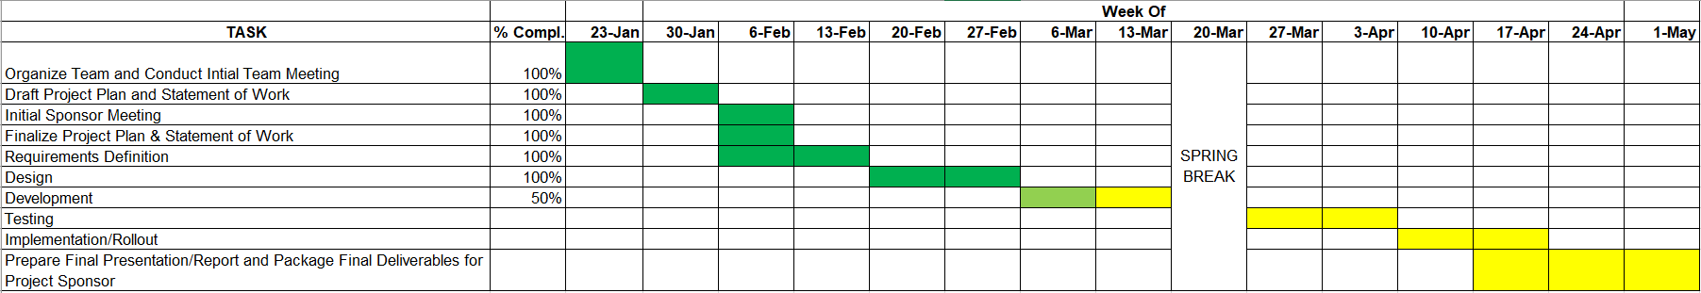

**Changes in the plan:**

We had to extend the development by a week since we were hoping to create the app using the Incorta platform but the scheduled certifications were off by a week and we had to take a different approach. This was adjusted with the Implementation and Rollout since most of the implementations were done during the testing phase.

Initially the Training and Certifications were not taken into consideration in the project plan so we had to incorporate that into the plan utilizing the Spring Break week.

**Final Gantt Chart:**

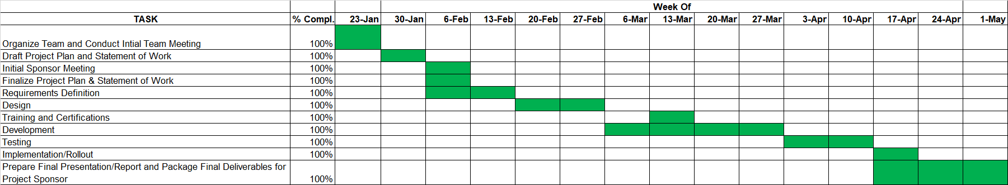

**Solution & Deliverables:** The deliverables include the working application which uses the user’s location to fetch the longitude and latitude, which would identify the nearby healthcare facilities. The application suggests the top 3 healthcare facilities with the minimum wait time and commute time at the time of emergency.

The solution involves imputing the missing values using k-Nearest Neighbors and utilizing time series forecasting to predict the waiting time when the patient reaches the facility.

**Next Step for the Sponsor**: The next step for the sponsor would be to enhance the visual aspect of the application and launch or sell the application.

**Conclusion:** The project has been a great learning experience. We have learnt:

* About the Incorta Platform and got certified
* How to develop a mobile application using Kivy and implement it using Buildozer
* How to deal with changing scopes
* You cannot go through with all the ideas
* Sometimes, the simplest method turns out to be the best method
* Always keep a buffer time period to accommodate any changes in the project timeline